Virtual sensor report

Key variable summary:
Key input: [Toque, P_0, T_IM, P_IM, EGR_Rate, ECU_VTG_Pos]
Potential input: [MF_FUEL], [p_21], [p_31], [T_21], [T_31], [q_MI], [Rail Pressure]
Output: [MF_IA, NOx, SOC]
Step 1: clean and prepare data
Add processed cvs file -> only leave numerical data
Statistics summary
Must take input statistical summary
Statistic | Torque | p0​ | T_IM | P_IM | EGR_Rate | ECU_VTG_Pos
count | 217.000000 | 217.000000 | 217.000000 | 217.000000 | 217.000000 | 217.000000
mean | 1129.794063 | 1.013032 | 50.199817 | 1.883465 | 23.730614 | 32.850497
std | 681.300676 | 0.000570 | 9.196098 | 0.771776 | 8.140916 | 10.333364
min | -0.042015 | 1.012210 | 31.000670 | 1.029631 | 3.286933 | 15.100000
25% | 602.982100 | 1.012468 | 42.691460 | 1.209819 | 19.425220 | 24.925000
50% | 1040.008000 | 1.013100 | 52.396680 | 1.655484 | 24.715320 | 31.004460
75% | 1571.976000 | 1.013578 | 55.900300 | 2.394424 | 28.976458 | 40.000000
max | 2606.458000 | 1.013860 | 69.899570 | 3.836457 | 43.376670 | 72.324840

Output statistical summary:
Statistic | MF_IA | NOx_EO | SOC
count | 217.000000 | 217.000000 | 217.000000
mean | 712.738224 | 433.682002 | -2.841450
std | 374.383776 | 318.325382 | 3.168160
min | 146.187200 | 105.847800 | -8.179352
25% | 424.982100 | 239.568600 | -4.972420
50% | 632.867200 | 331.214700 | -3.588317
75% | 979.179000 | 465.577900 | -1.027823
max | 1632.780000 | 1579.938000 | 5.085567

Step 2: Explore data (data visualization)
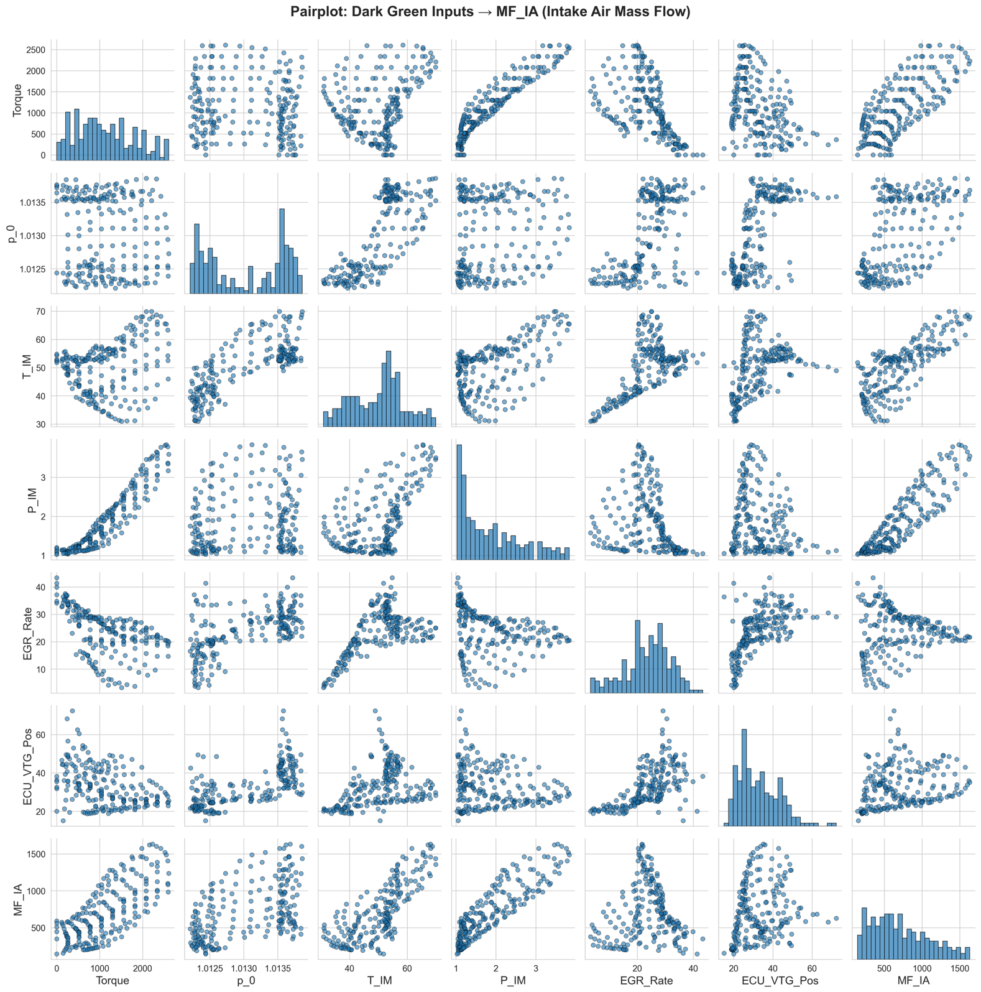
Moderate Scatter, non-linear
Negative trend overall
Strong positive relationship (linear)
Moderate Scatter, non-linear
Very scattered spread out
positive relationship (nonlinear)
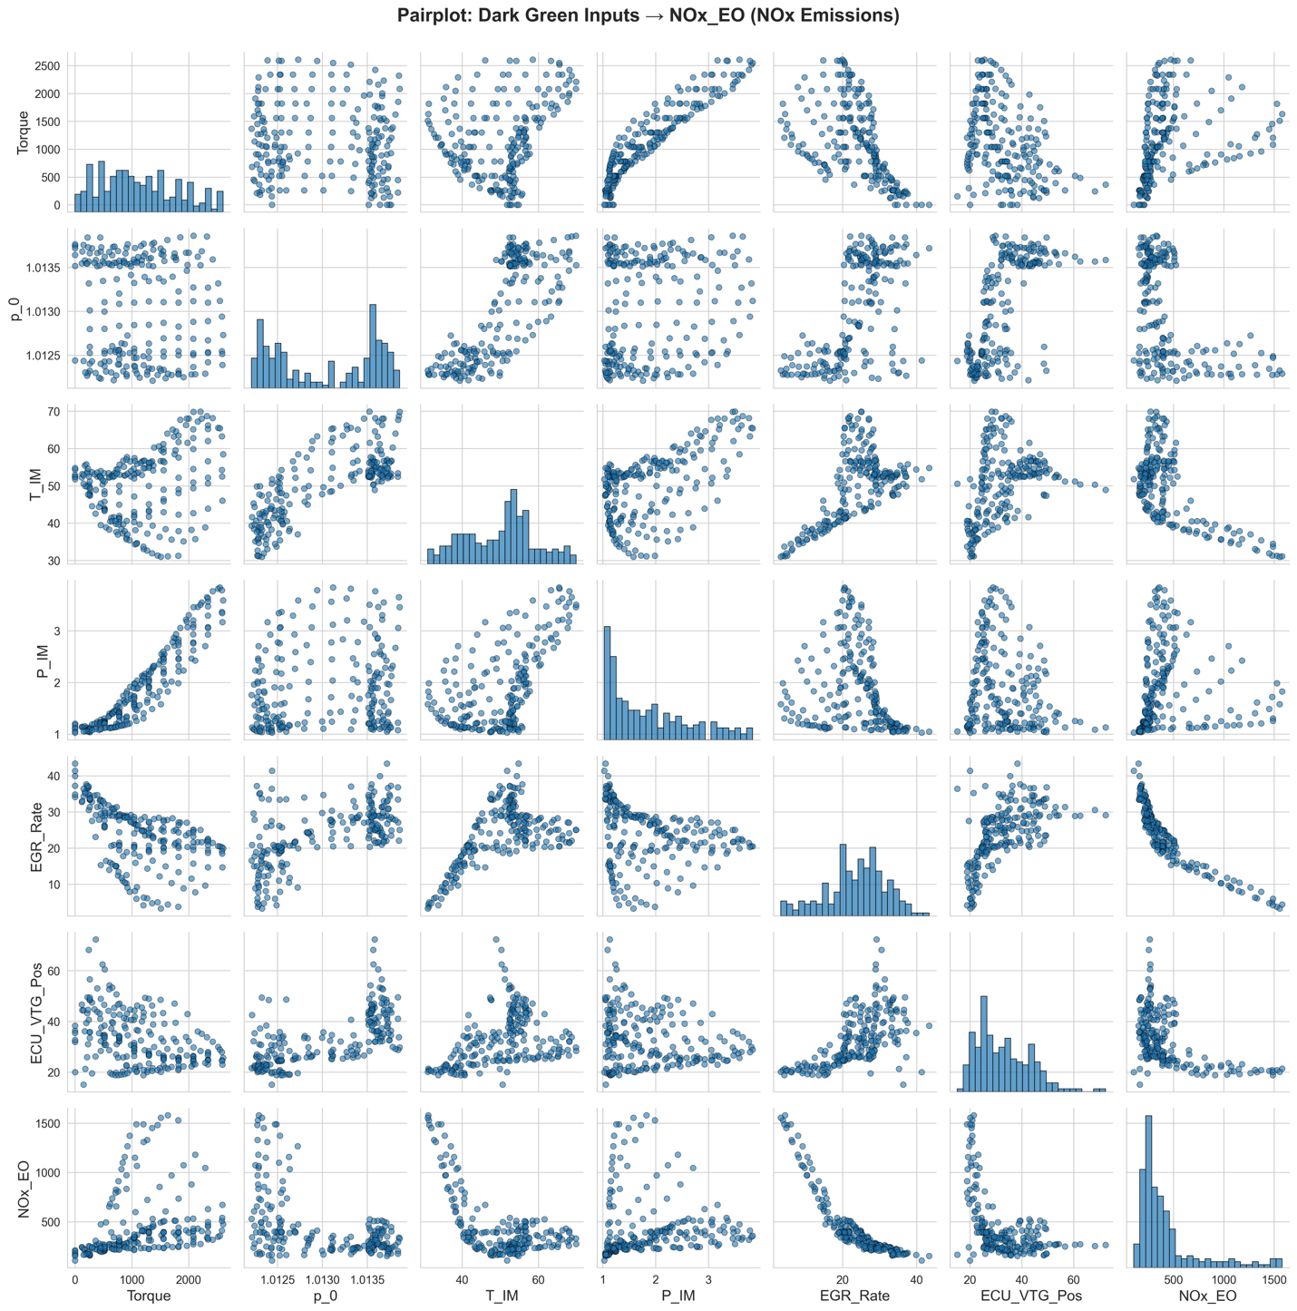
Inverse, nonlinear trend
Inverse, nonlinear trend
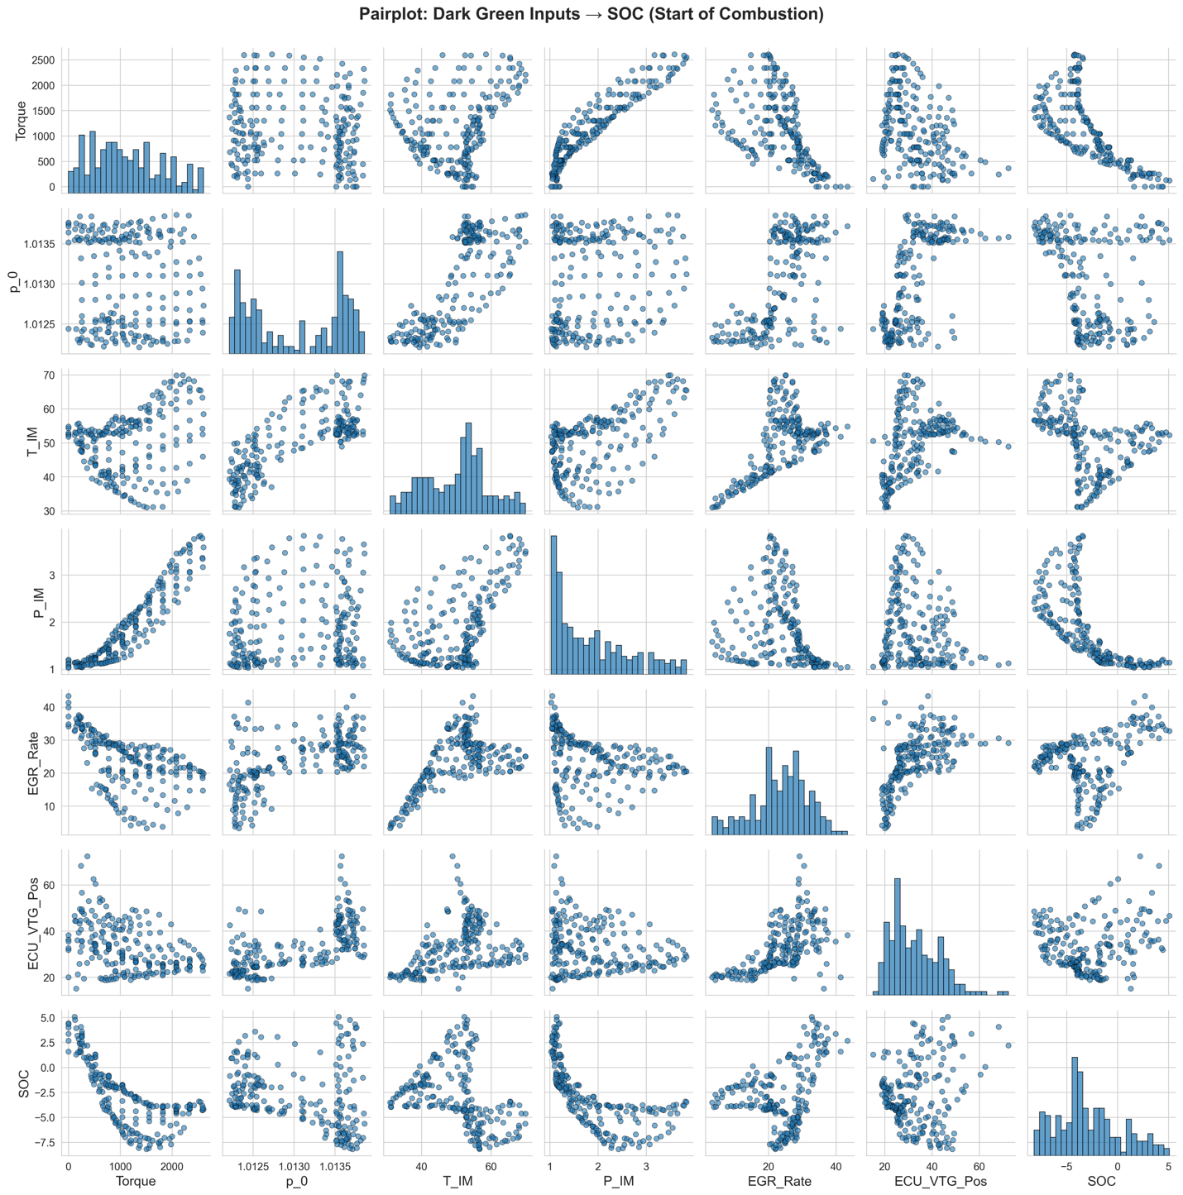
Inverse, nonlinear trend
Inverse, nonlinear trend

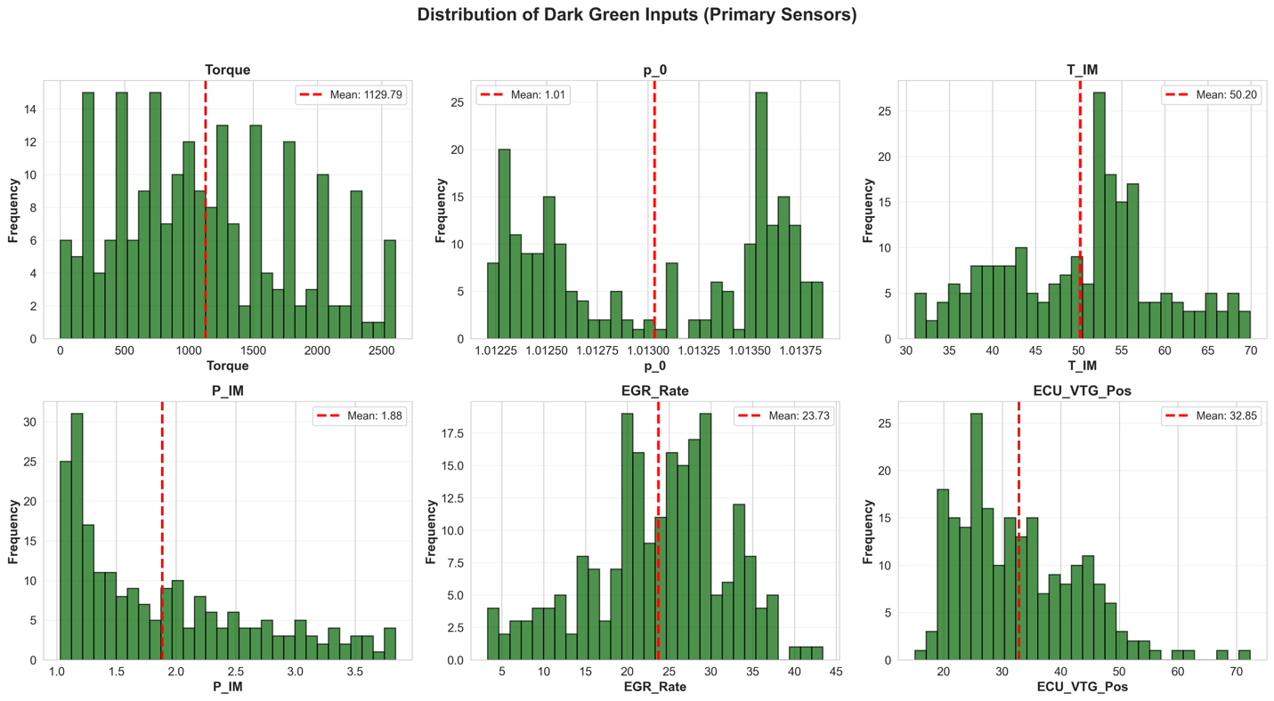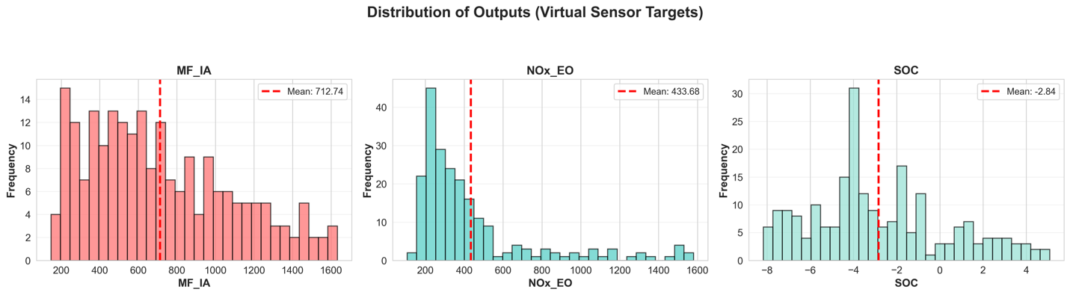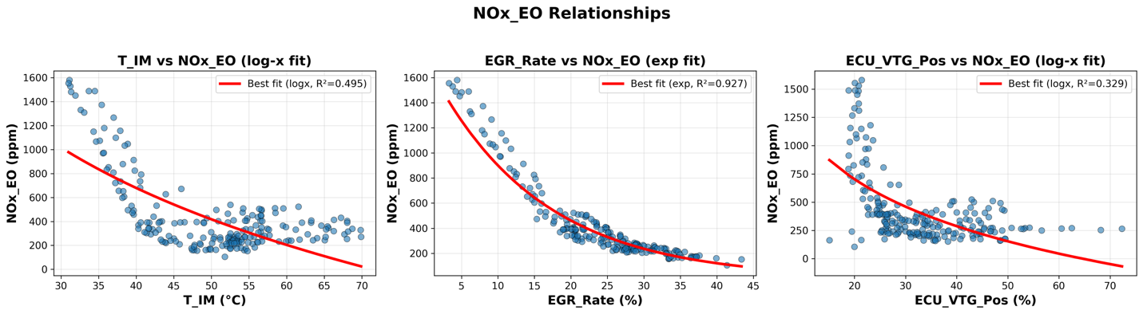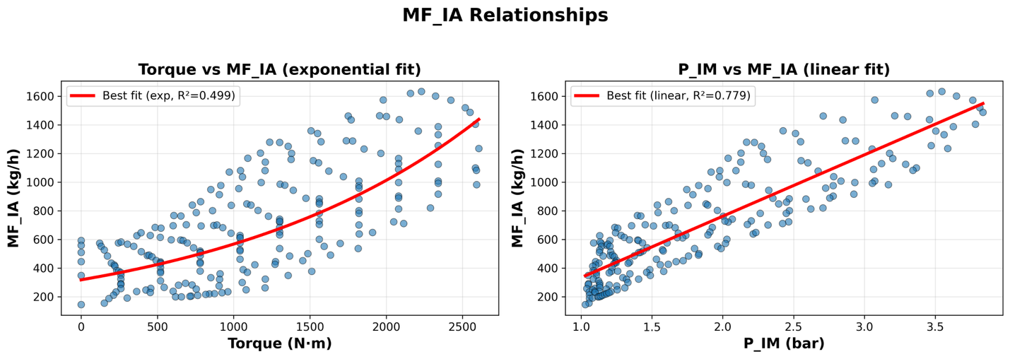
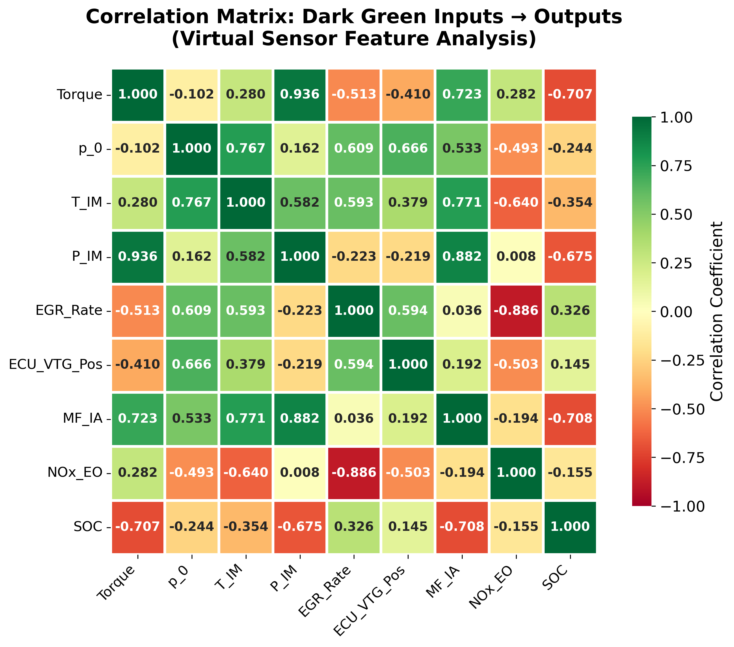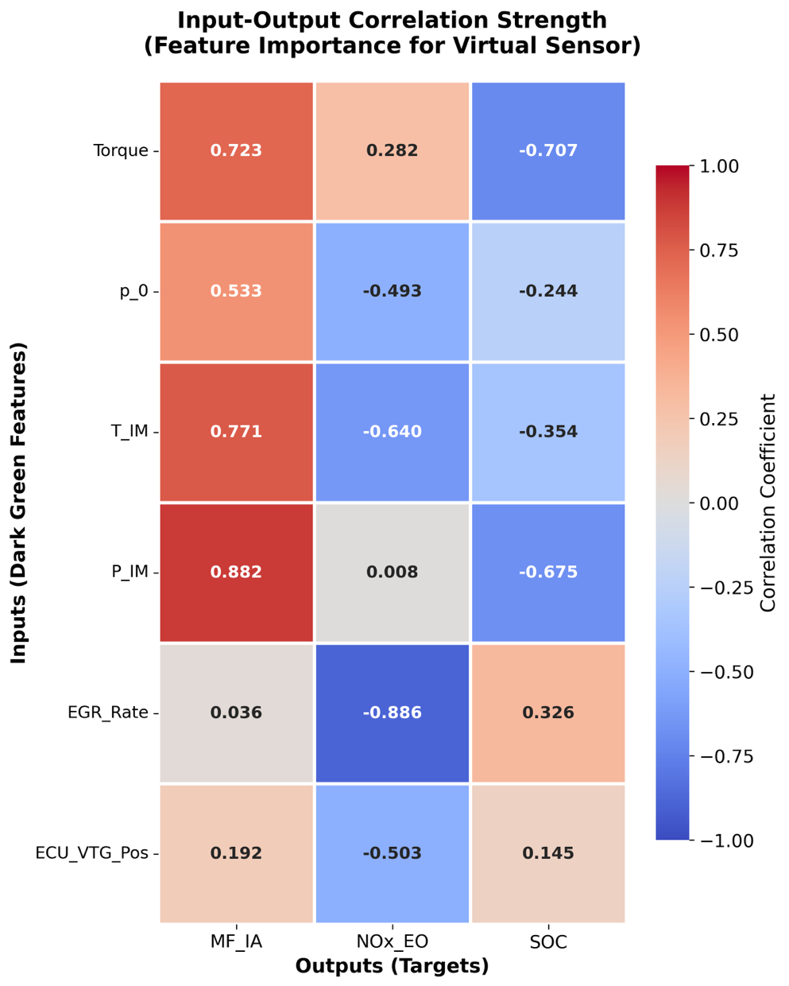

Model construction:
Metric | Value
Total Samples | 217
Training Set | 173 (80%)
Test Set | 44 (20%)
Key Input Features | 6
Potential Input Features | 7
Output Variables | 3
Split Method | Random stratification (seed=42)

Simple Linear regression baseline test:
Dataset: 217 samples, 6 key inputs
Train: 173, Test: 44 (80-20 split)
MF_IA: (this works best for linear regression)
------------------------------------------------------------
Train: MAE=56.1156, RMSE=68.9385, R²=0.9655
Test: MAE=49.9015, RMSE=63.1209, R²=0.9729

NOx_EO:
------------------------------------------------------------
Train: MAE=89.0385, RMSE=119.1466, R²=0.8423
Test: MAE=89.9053, RMSE=130.5954, R²=0.8780

SOC:
------------------------------------------------------------
Train: MAE=1.2814, RMSE=1.6280, R²=0.7459
Test: MAE=1.3026, RMSE=1.6267, R²=0.6795 (slightly overfitting)

ANN model (key input):

Model overview:
6 key input -> 64 -> 32 -> 16 -> 1
Normalization: StandardScaler (zero mean, unit variance)

Dataset: 217 samples, 6 key inputs
Train: 173, Test: 44

MF_IA:
------------------------------------------------------------
Train: MAE=23.1013, RMSE=28.4242, R²=0.9941
Test: MAE=22.5687, RMSE=28.5363, R²=0.9945

NOx_EO:
------------------------------------------------------------
Train: MAE=20.5493, RMSE=28.5884, R²=0.9909
Test: MAE=29.7740, RMSE=39.0014, R²=0.9891

SOC:
------------------------------------------------------------
Train: MAE=0.1603, RMSE=0.2455, R²=0.9942
Test: MAE=0.2731, RMSE=0.3629, R²=0.9841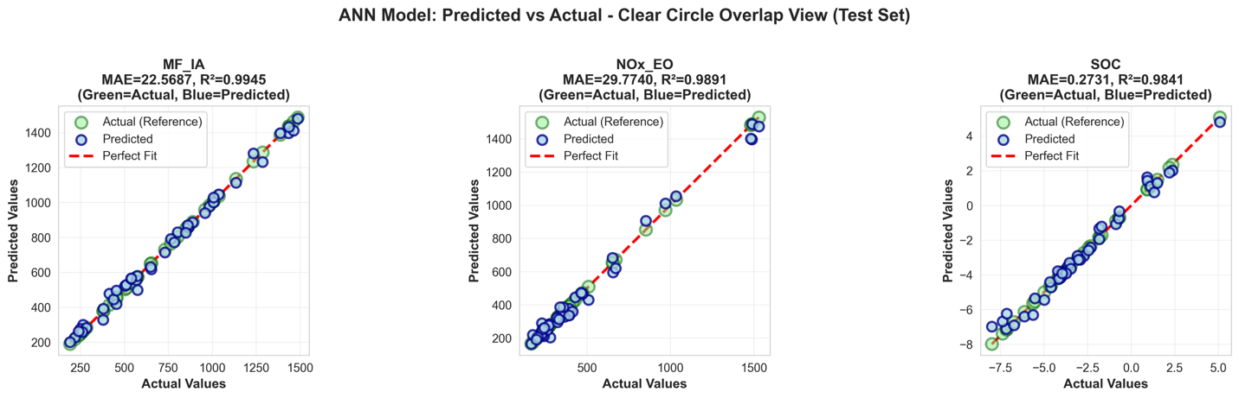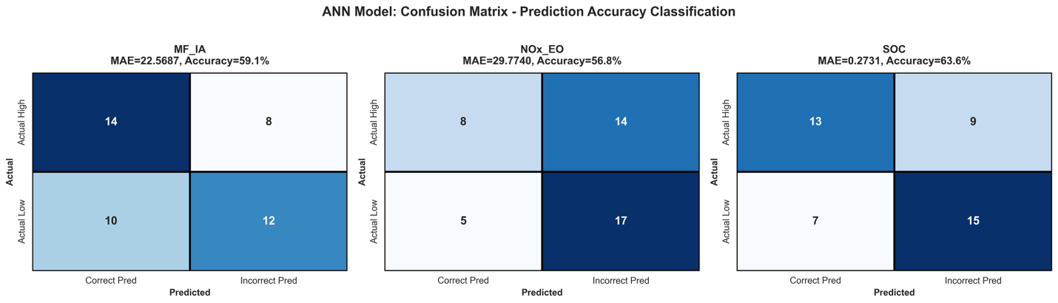
 | Precision | Recall | F1 score
MF_IA | 58.3% | 58.3% | 58.3%
Nox_EO | 61.5% | 36.4% | 45.6%
SOC | 65.0% | 59.1% | 61.9%

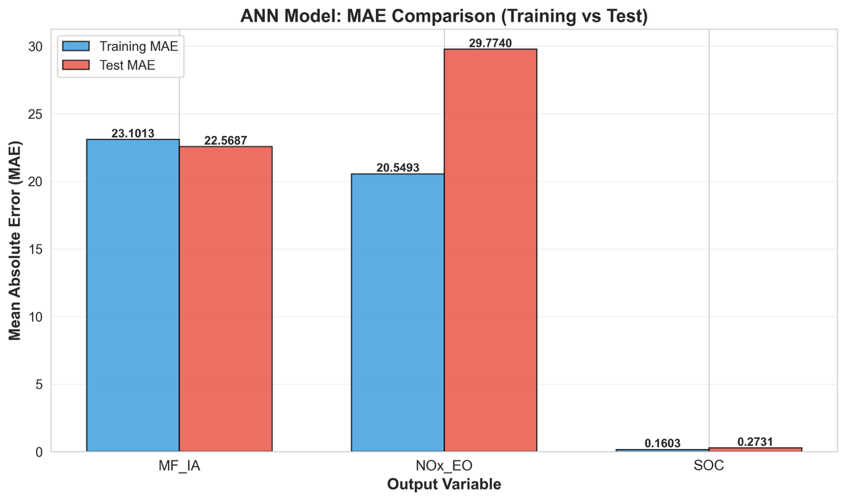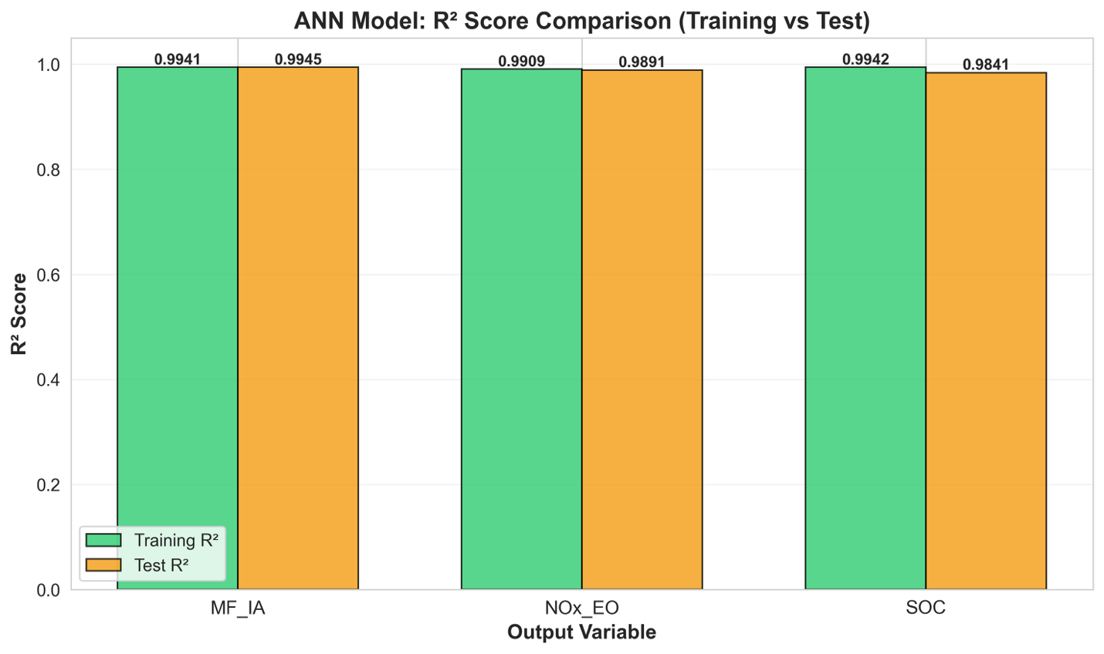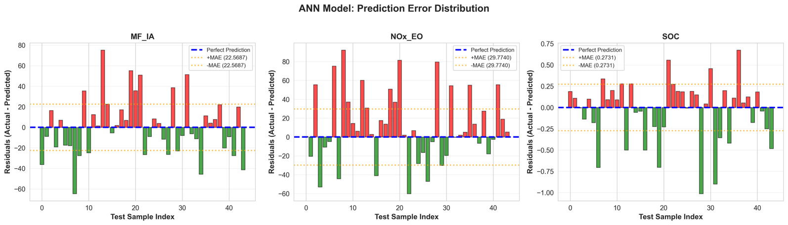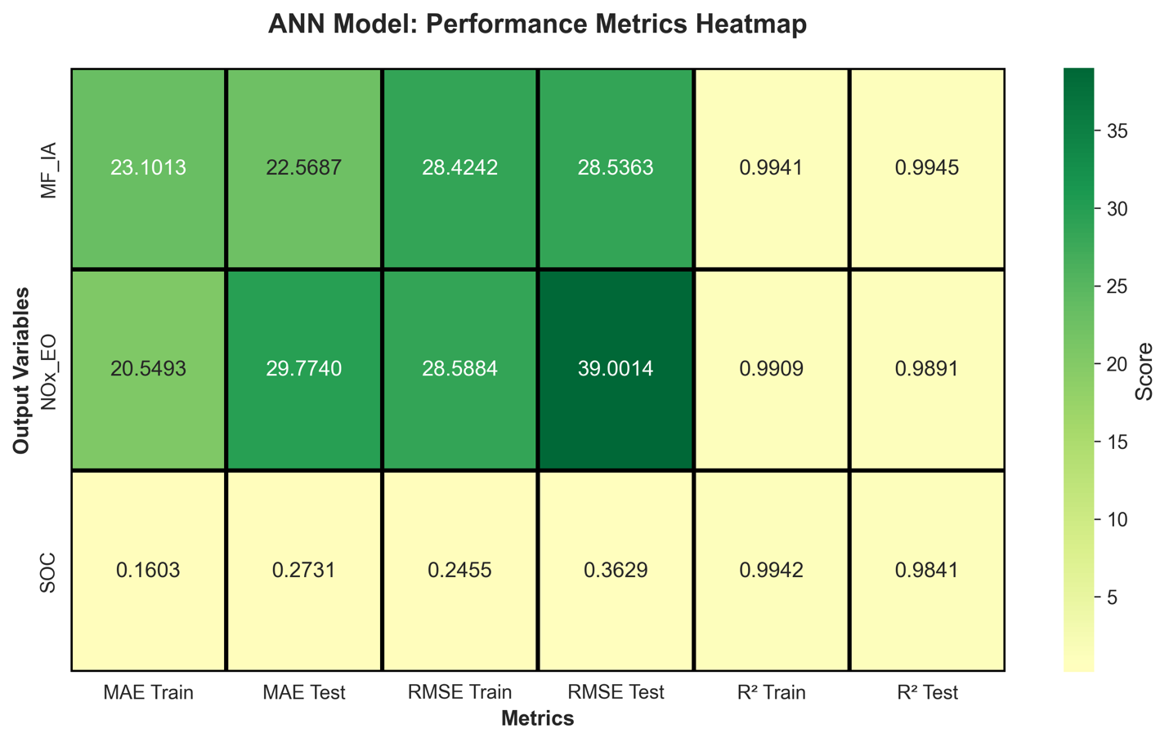
overfitting
overfitting

ANN model (both key + potential inputs):
Model overview: 13 -> 128 -> 64 -> 32 -> 1

Dataset: 217 samples, 13 total inputs
- Key inputs: 6
- Potential inputs: 7
Train: 173, Test: 44

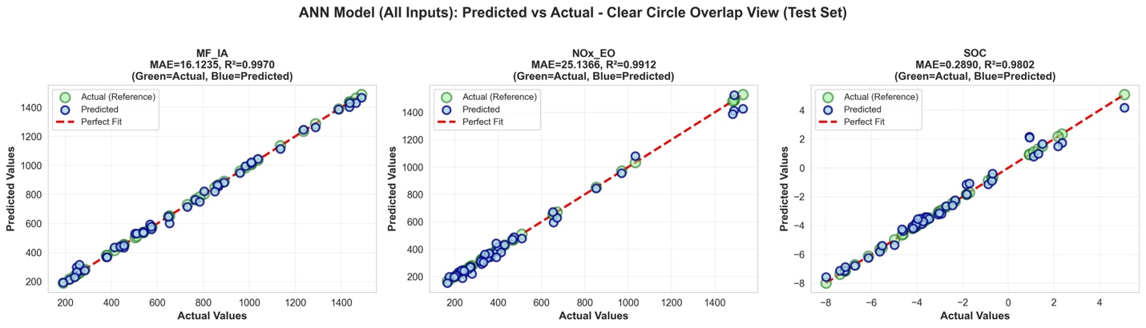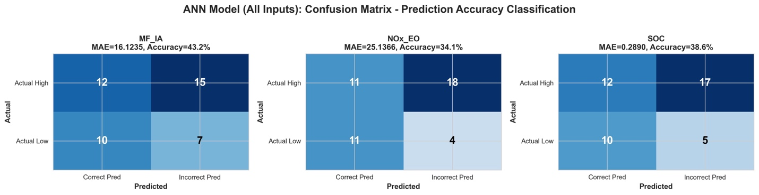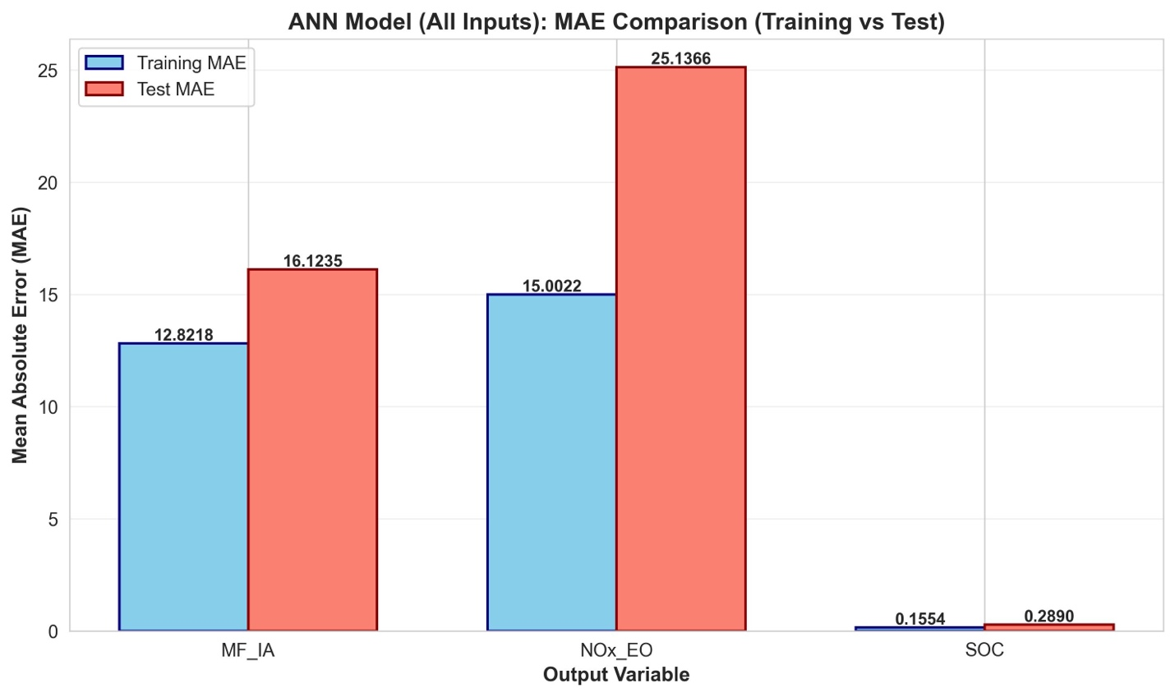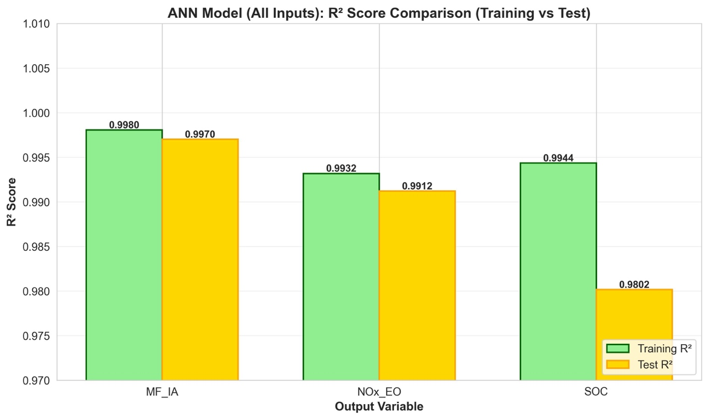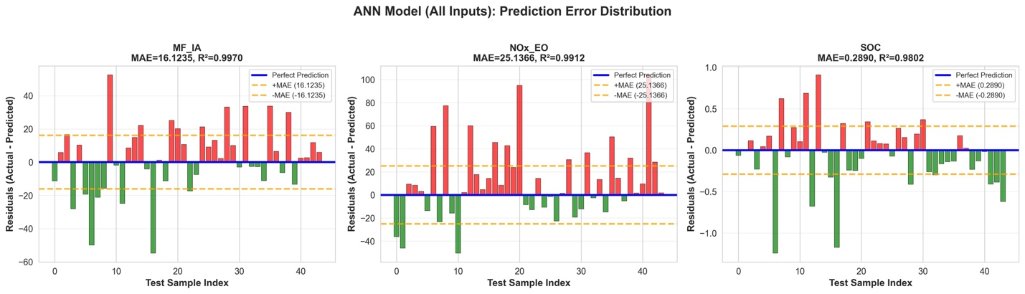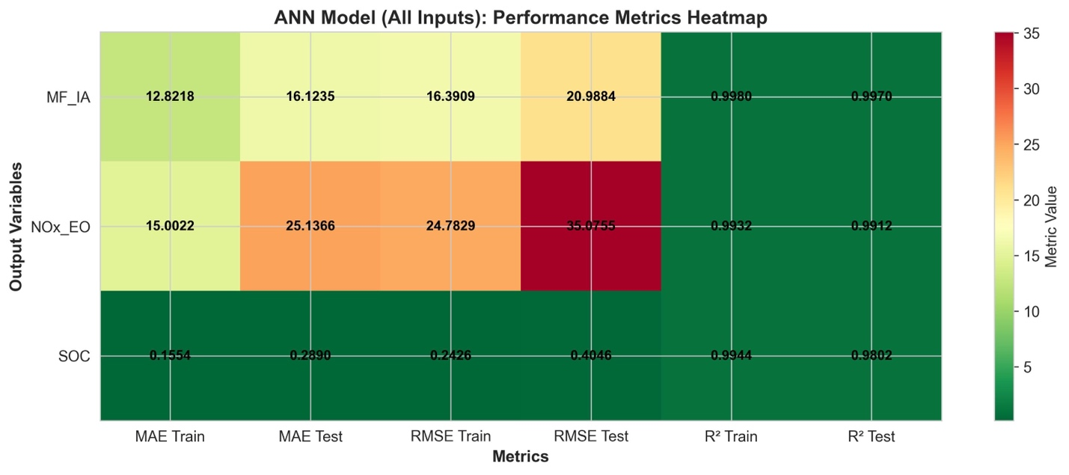

MF_IA:
------------------------------------------------------------
Train: MAE=12.8218, RMSE=16.3909, R²=0.9980
Test: MAE=16.1235, RMSE=20.9884, R²=0.9970

NOx_EO:
------------------------------------------------------------
Train: MAE=15.0022, RMSE=24.7829, R²=0.9932
Test: MAE=25.1366, RMSE=35.0755, R²=0.9912

SOC:
------------------------------------------------------------
Train: MAE=0.1554, RMSE=0.2426, R²=0.9944
Test: MAE=0.2890, RMSE=0.4046, R²=0.9802

Summary of all test results:
MF_IA:
Linear (6): R² ≈ 0.973, MAE ≈ 49.9 kg/h
ANN (6): R² ≈ 0.9945, MAE ≈ 22.6 kg/h
ANN (13): R² ≈ 0.9970, MAE ≈ 16.1 kg/h

NOx_EO:
Linear (6): R² ≈ 0.878, MAE ≈ 89.9 ppm
ANN (6): R² ≈ 0.9891, MAE ≈ 29.8 ppm
ANN (13): R² ≈ 0.9912, MAE ≈ 25.1 ppm

SOC:
Linear (6): R² ≈ 0.680, MAE ≈ 1.30 deg
ANN (6): R² ≈ 0.9841, MAE ≈ 0.27 deg
ANN (13): R² ≈ 0.9802, MAE ≈ 0.29 deg (worse)

Replacement of physical sensors:
Adding extra seven physical input sensors would only yield <0.02% R^2 improvement, while significantly increases the model hidden layer compelxity, costs of buying physical sensors, and overfitting risks.

Virtual sensor (ANN- embedded in ECU)
Real-time sensor data
Sampled every engine cycle
Torque p_0 T_IM P_IM EGR_rate VTG
Physical sensor (6 key input)
Virtual sensor system

ANN model (6 -> 64 -> 32 -> 16 -> 3)
-trained on historical engine data
-runs in <1 ms per cycle

Predicted outputs
Virtual outputs (replace 3 physical sensors)
MF_IA Nox_EO SOC
MAE ±22.6 ±29.8 ±0.27

Financial analysis angle on replacing physical sensor:
Aspect | Physical Sensors (Hardware) | Virtual Sensor (Model-Based)
Components Measured | MF_IA, NOx_EO, SOC | MF_IA, NOx_EO, SOC (Derived)
Additional Hardware | Dedicated sensors/analyzers required for each (e.g., MAF meter, NOx bench analyzer, pressure transducers). | None required per vehicle (reuses existing engine sensors/ECU) OR low-cost edge box ($50–$2,000) for dedicated inference.
Initial Hardware Cost | $1,500 – $23,000 (Varies wildly, largely driven by the cost of the high-accuracy $NOx$ analyzer). | None (per vehicle, if running on existing ECU) OR $50–$2,000 for a dedicated inference unit.
Development Cost | Minimal (off-the-shelf purchase). | One-time ≈ $3,000 – $150,000+ (Research project: $25k–$50k; Industrial-grade: $150k+).
Installation Cost (Per Unit) | $500 – $1,500 (Labor, fittings, harnesses). | ≈ $0 – $2,000 (Software-only: firmware/ECU update; or installation of small edge unit).
Installation Time | Hours to Days. | Minutes to Hours (Software deployment).
Calibration | $200 – $1,500 / vehicle (Initial and periodic gas calibration/verification). | Minimal to None (Relies on model validation during development).
Annual Maintenance | $100 – $2,000 / sensor / year (High maintenance for bench analyzers; low for simple MAF). | $500 – $5,000 /yr (Software monitoring and periodic model retraining/updates).
Lifespan | 3 – 10 years (Physical components degrade). | 5 – 15+ years (Software lifespan depends on continued compatibility with ECU/hardware).
5-Year Total Cost | ≈ $3,000 – $50,000+ per unit (The cost is multiplicative with the number of units/testbeds). | << Hardware alternative when amortized over many vehicles.  one-time dev $50k amortized over 100 vehicles => ~$500/vehicle + negligible upkeep
Return on Investment (ROI) | N/A (Required capital expenditure). | Typically 10–500× when amortized over a large fleet, depending on the need for costly NOx hardware.

Neural Netwrok architecture
Tier 1: MLP (Primary real-time virtual sensor)
- 6 normlazed key inputs
- Activation: ReLU
- Latency: <1 ms on modern ECU-class hardware
Tier 2: LSTM (Temporal monitoring and drift detection)
- Goal: detect slow drifts or degradation in inputs-outputs
- Run at lower frequency to monitor consistence between MLP predictions and temporal pattern.
Tier 3: Ensemble of MLPs (Uncertainty quantification)
- Quantify prediction uncertainty and increase robustness
- Trian 5-10 MLP but diff initialization
Tier 4: Autoencoder (Sensor pattern anomaly detection)
- Detect abnormal regimes or sensor faults
- Train an autoencoder to reconstruct normal sensor patterns. Large reconstruction error indicates an anomaly
- Raise warnings when reconstruction error exceeds a calibrated threshold

ECU-Centric Deployment
- Tier 1 (MLP): Runs every engine cycle or at fixed time intervals (e.g., 10 ms). Its outputs directly substitute MF_IA, NOx_EO, and SOC sensors in control or monitoring algorithms.
- Tier 4 (Autoencoder): Runs at a lower rate in the background to track the health of the six input sensors and detect unusual operating points.
Optional Cloud/Backend Components
- Tier 2 (LSTM) and Tier 3 (Ensemble): Can be deployed in the cloud or on an off-board server, consuming logged data from vehicles to perform deeper analysis (drift, uncertainty) and to drive periodic retraining.
Update & Retraining Policy
- Monthly: Retrain the MLP and auxiliary models using the latest aggregated field data; validate on a held-out test set.
- Quarterly: Roll out updated models to the fleet if they pass acceptance criteria (e.g., R² ≥ 0.985 on all outputs).
- Annually: Perform detailed validation vs. ground-truth lab measurements if available.

